SOCIAL STORY FOR FAMILY VISITS WITH YOUNGER CHILDREN.
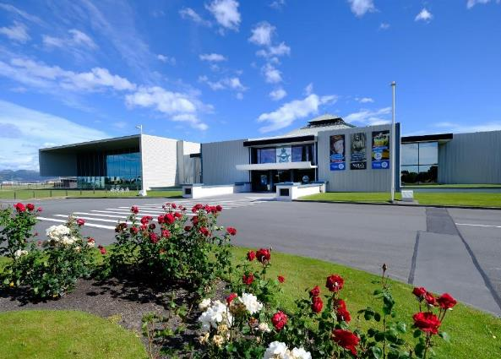
My Trip to the
Air Force Museum

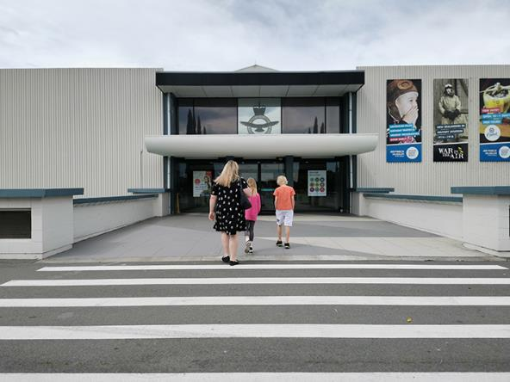
I am going to the Air Force Museum. The Museum is a place where you can find a lot of different things to look at and learn about to do with the air force, its aircraft and its people.

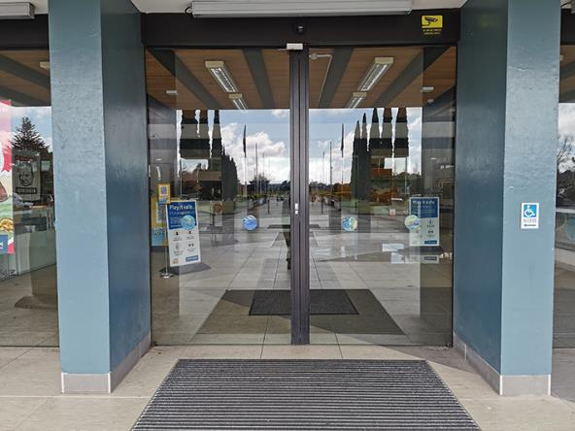
To get into the Museum, I go through the front doors.

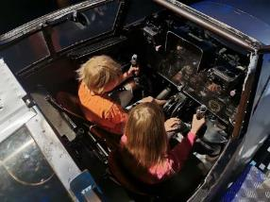 | 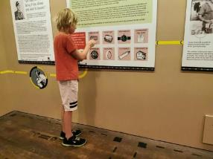
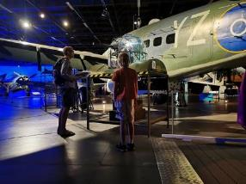 | 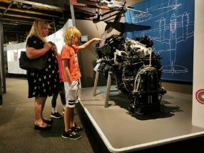
There are interesting things to do and see at the Museum.

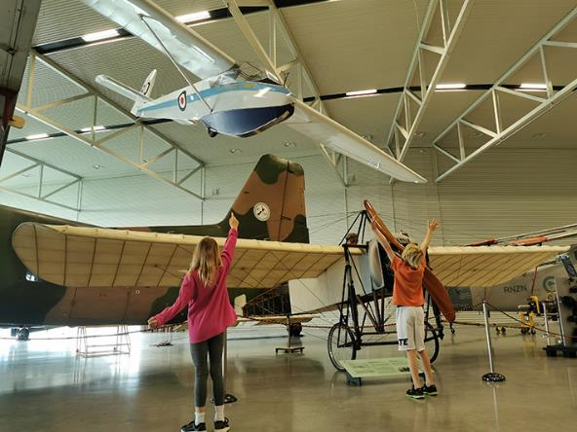
I will see aircraft hanging from the roof. The engineers have secured the aircraft very strongly to the roof.

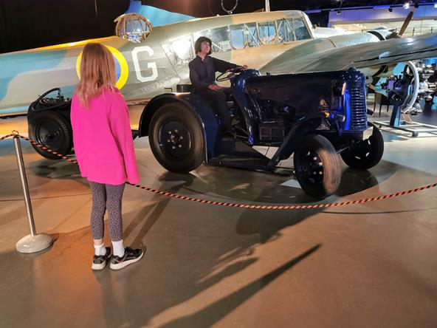
I will see pretend people (mannequins). They look real, but they are not.

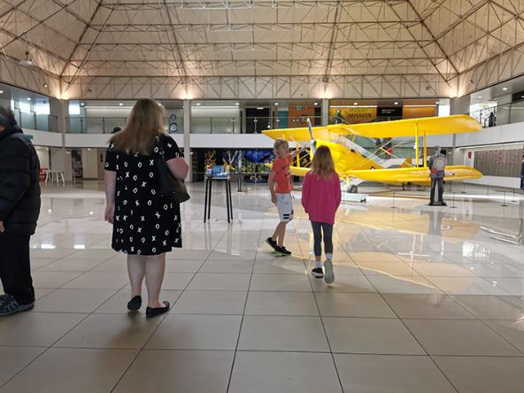
When I am at the Museum, I will do my best to stay with my adult. This will help me to stay safe.

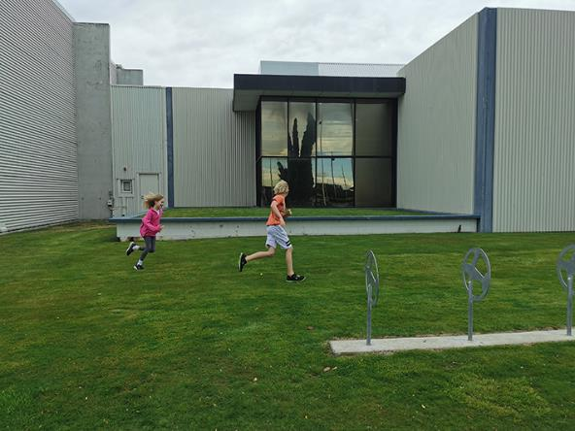
If I need to run around, I can ask my adult to take me outside.

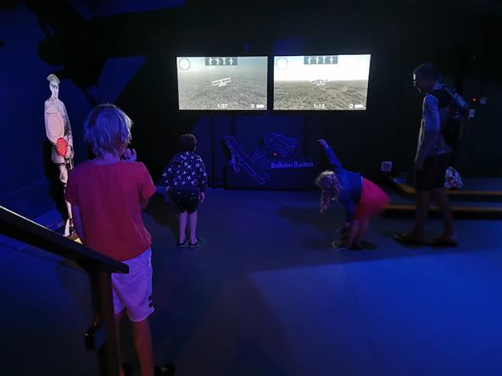
There are things I can touch and activities I can do at the Museum. Other people will want to have a turn at these as well. I will do my best to take turns and share with other people. My adult can help me with this.

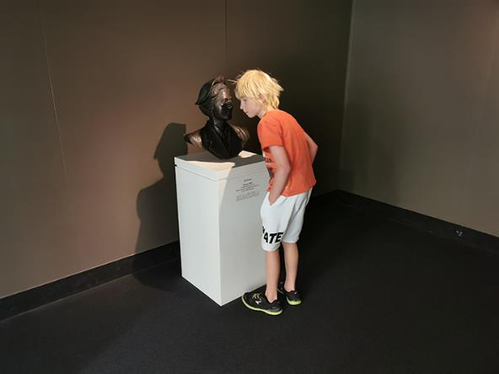
I will do my best to talk in a quiet voice at the Museum. Other people are at the Museum too and they might want to talk and hear each other.

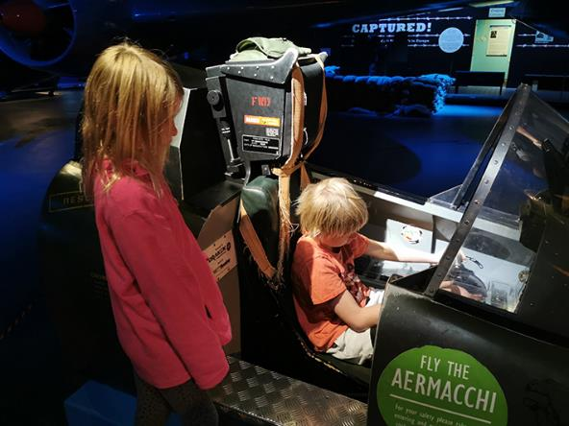
At the Museum there are some displays people can touch. There are also some displays people are not allowed to touch. This is OK. The Museum is keeping their displays safe. There is usually a rope or barrier in front of things I cannot touch. If I am unsure, I can ask my adult if I can touch.

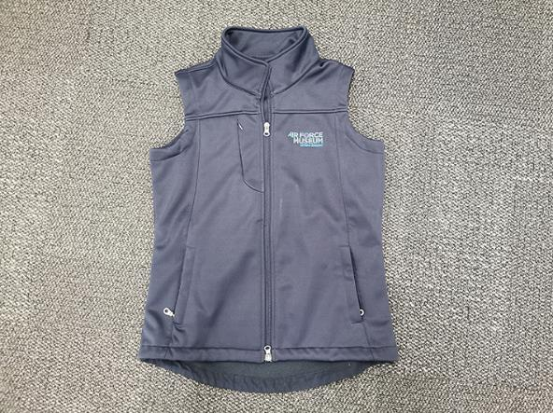
If I get lost, I can ask a Museum guide for help. Guides wear dark blue vests.

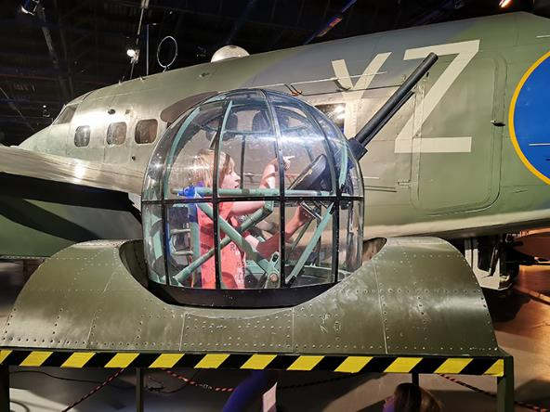
The Museum can be a fun place to visit. If I have not seen everything I want to see, I can come back another day to the Museum and see them.

